**Project Details**:-

**ChetuGlobalATS-INTL**

* [**URL:-**](URL:-) <http://atsservice.chetu.com/>
* **Credentials:-** All Authorized members

**Database Details**:-

* [**Server:-**](URL:-)APPDB01\APPDB01
* **Password:-** IT5ngr13v@123
* **Database Name:-** ats

**FTP Account Details**:-

* **IP**      :               10.0.0.32
* **Port**     :               990
* **User**     :               appdb01ftp
* **Pass**     :               a**dB01$@f6p2

**Description of the project:-**

**Login Page:-**

* Firstly, there is the **Login Page** which authenticate the user to use the application.
* When someone get logged in then there are six tabs.

**Resourcing Tab:-**

* On Dashboard, there is a grid which contains all the record of requests that has been made till now, which we also call Resourcing.
* **New Resource Request:**This option is used to issue new request . The dialog box includes Due Date, Technology, Resource type, experience and priority of the request. The request can be issued by FMs and admin.

* **In-Process**: This pop up shows all the requests which are in process. In process requests are those requests which are assigned to some Jobs TL for processing.

* **Export Excel:** The data which is display on the frontend can be exported to excel with the help of this option.
* **Opening Allotment:** A request issued can be assigned to some Jobs TL for further processing.

**Opening Tab:-**

* This module contains Request in three categories namely-In-Process, Complete and Offered
* Under shortlisted caption we will get all the records of the candidate that has been currently linked to the given Opening id.
* Search candidate option is used to link other candidates to the given Opening Id.

**Hiring Candidate Tab:-**

* This module contains those records who are ready for CBT(Computer Based Test). These candidate will then be available for linking to an opening.

**Track Candidate tab:-**

* This module is use to register new candidate. The Add candidate form contains all necessary information such as mobile no, email id, dob etc to be mandatory.
* Also from this module we can send mass sms/mail to the selected or all candidates.

**Naukri Portal tab:-**

* If a candidate has registered on the naukri.com then that data can be linked to ATS application through this module.

**Offer tab:-**

* When a candidate is moved from Opening section to Offer, then that candidate is now eligible to be given Offer.
* This module is also responsible to generate Offer Letter and sending record to Verification section

**OnBoarding tab:-**

* This module contains the records who have finally signed their Offer letter and are ready to join the company. From this module we assigned employee code to the candidate.

**Screenshots:-**

**Login Module**

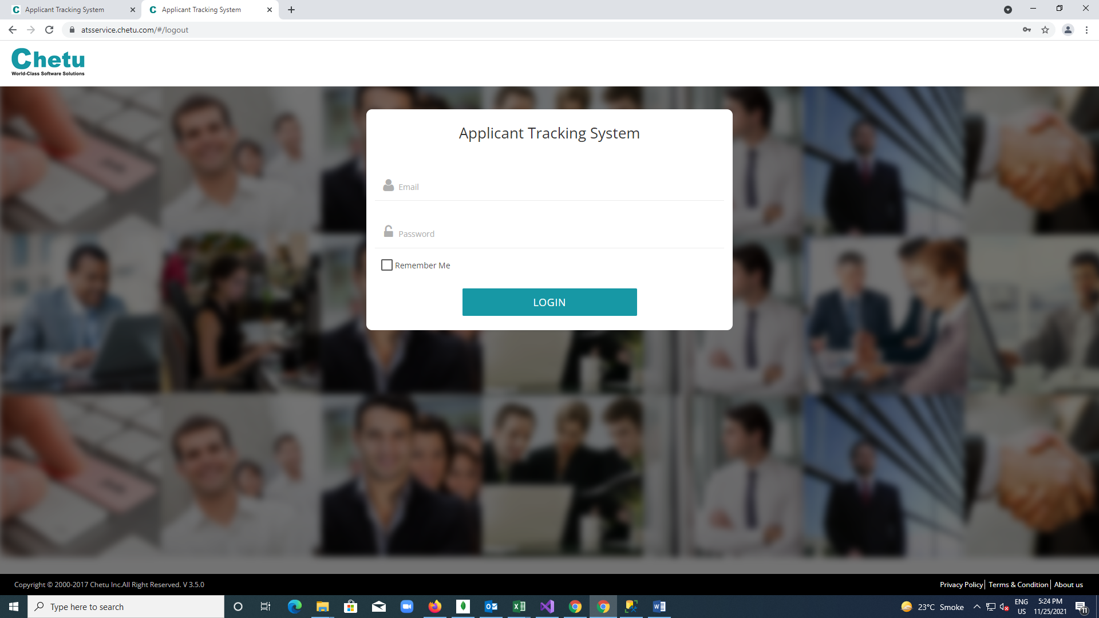

**Resourcing Module**

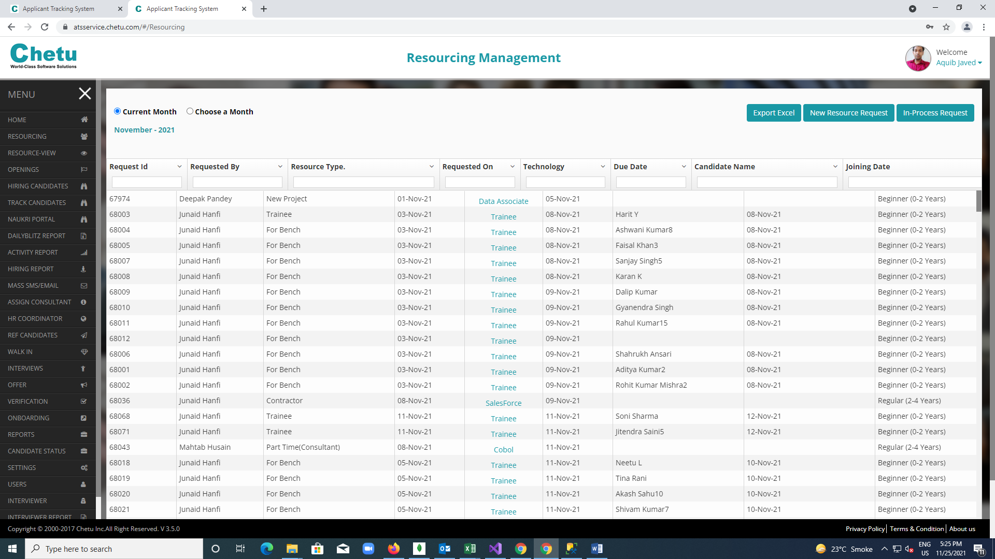

**New Resource Request**

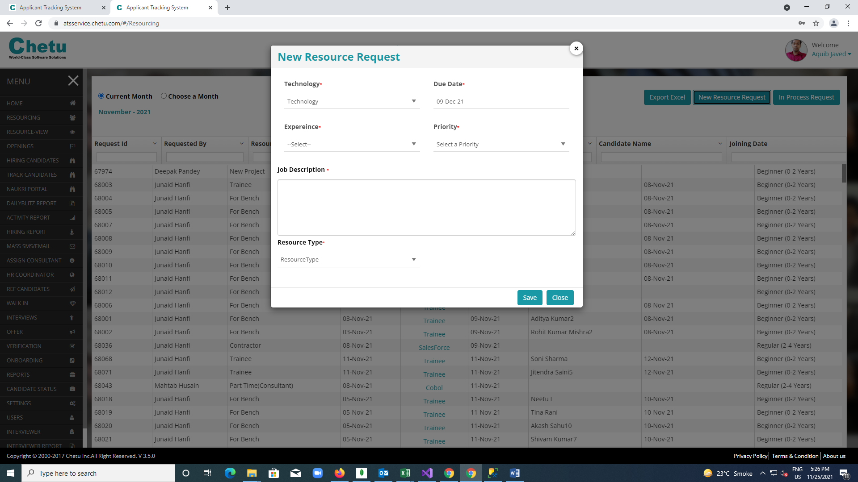

**Opening Module:**

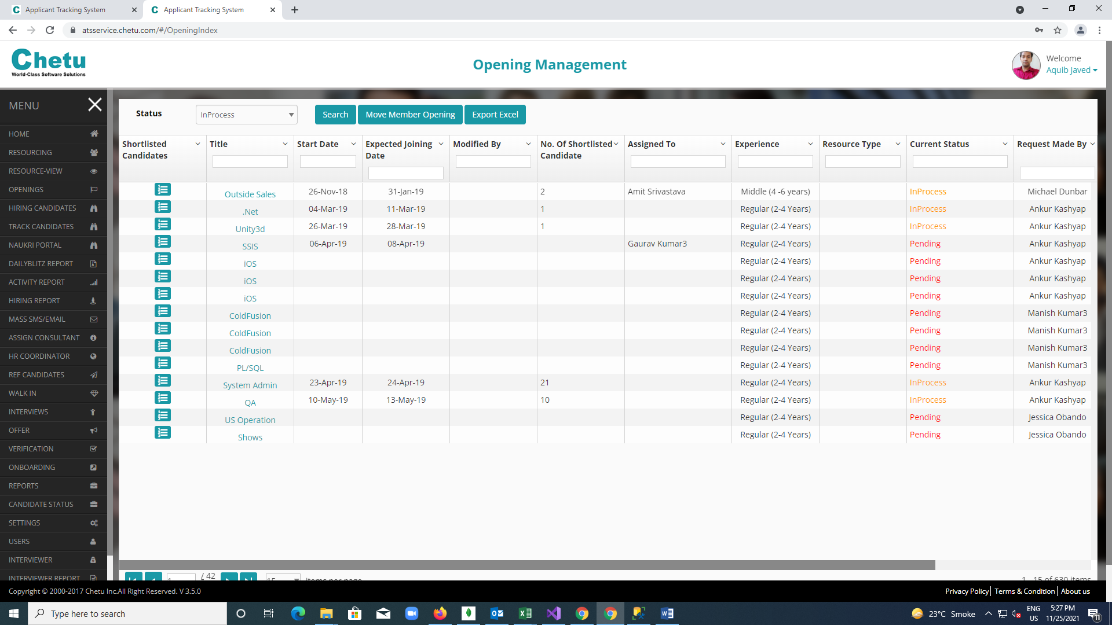

**Shortlisted Candidates:**

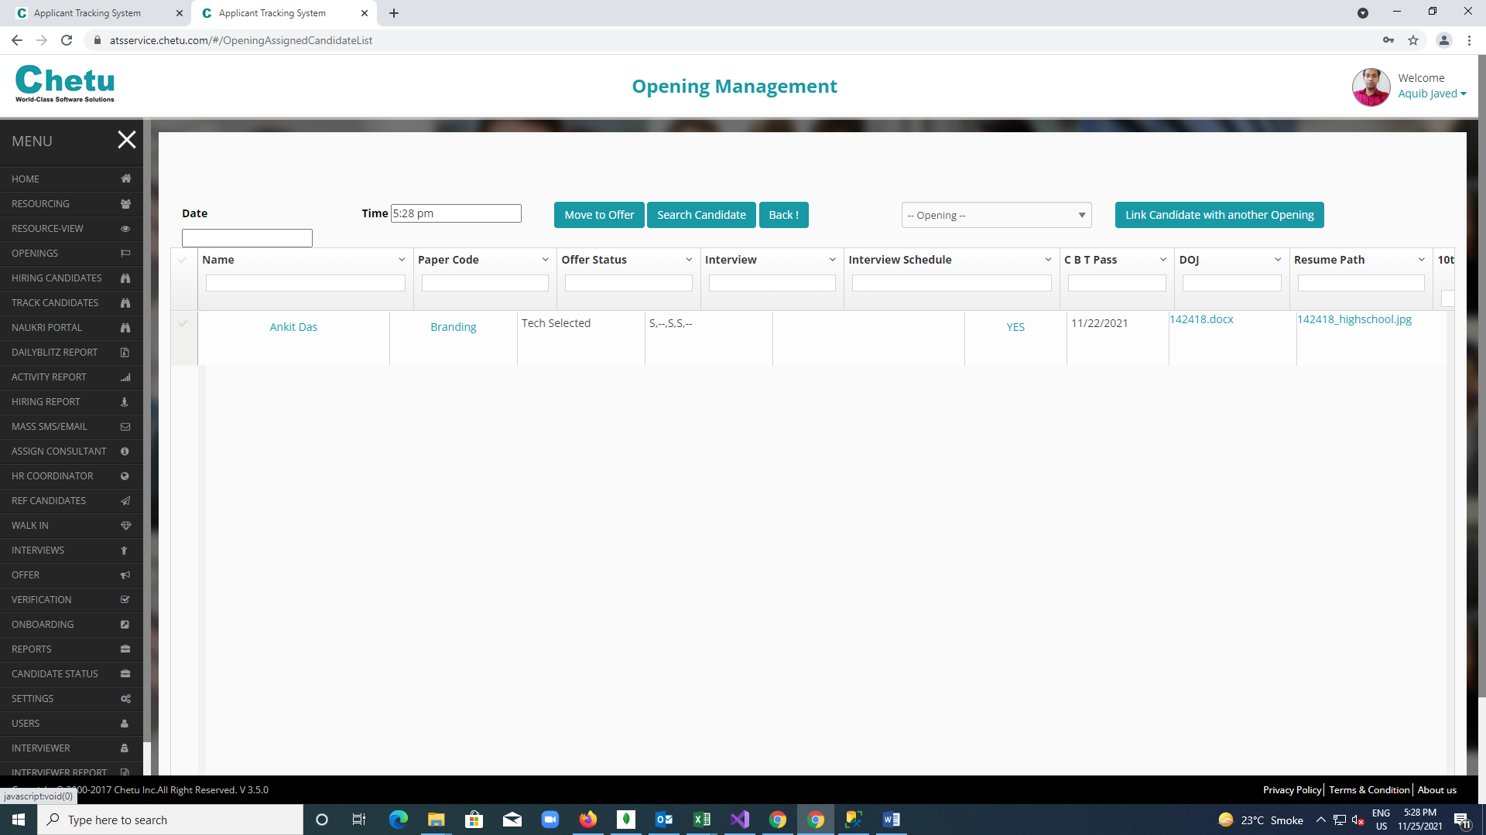

**Offer Module**

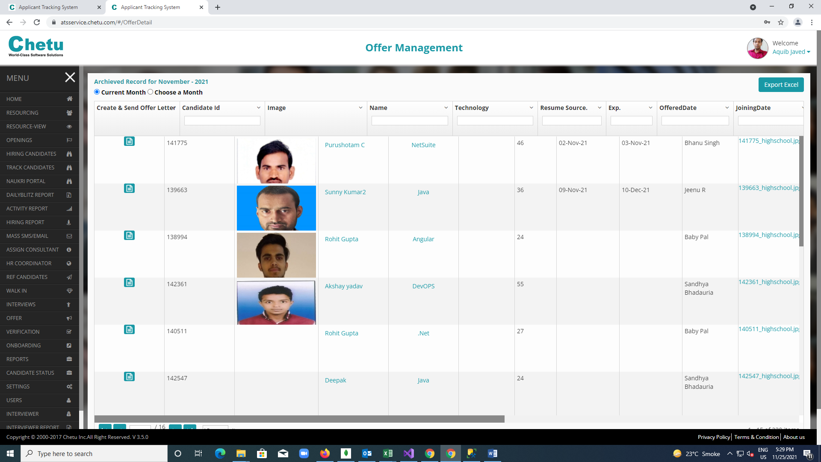

**Create offer letter section**

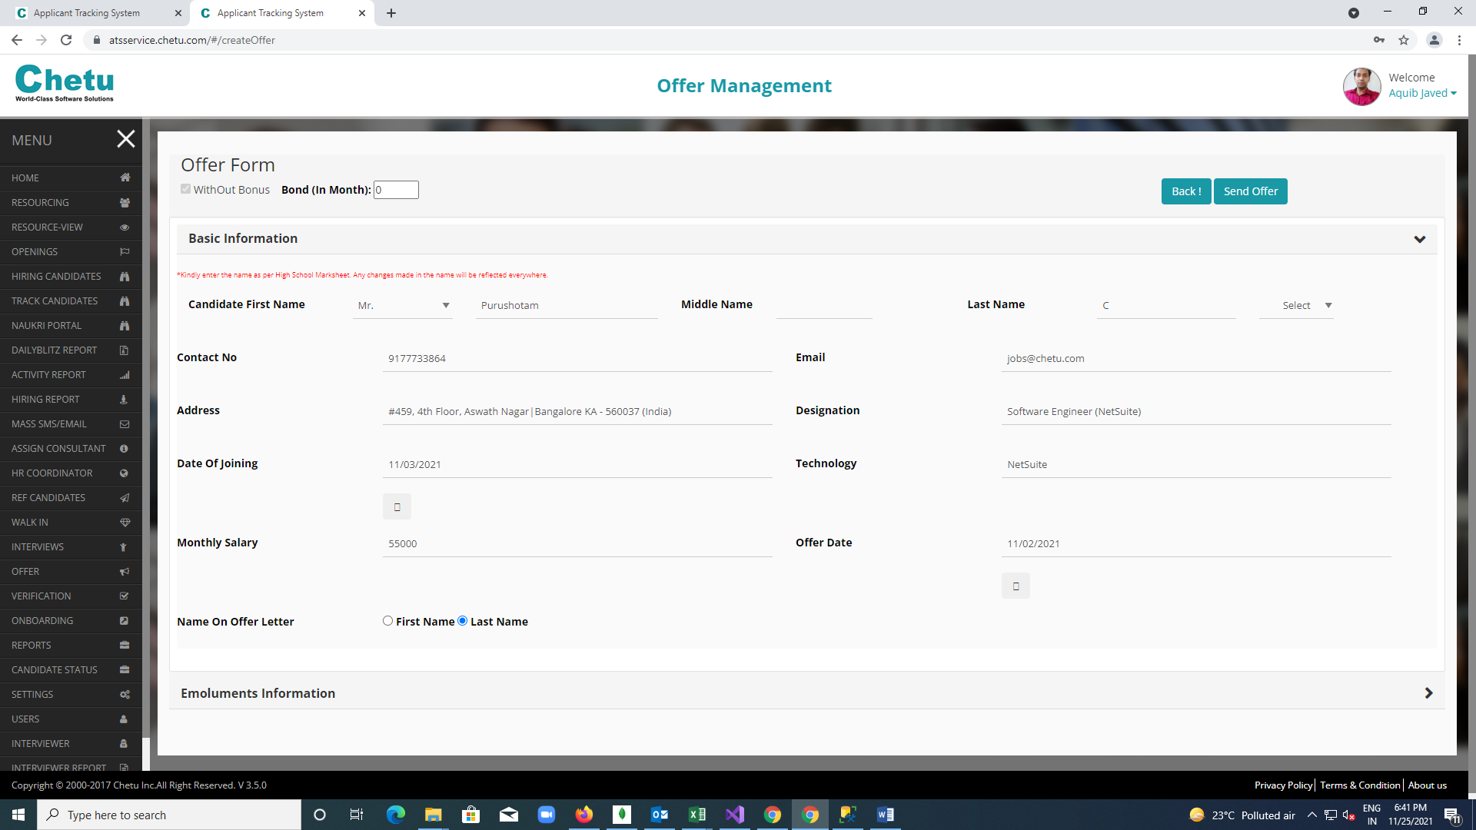

**Onboarding module** 